Week 3 Lab Task
Scanning & Enumeration
NIAI NAVTTC — Certified Ethical Hacker (CEH) Course
⚠ Important: All tasks must be performed only in your isolated virtual lab environment. Never test on real networks or systems without explicit written permission.

Task: Conduct a comprehensive network scan to identify all active hosts and services. Perform vulnerability scanning on identified hosts. Perform active enumeration on a Windows-based network to identify Active Directory users, groups, and systems.

Step 1 — Set Up Your Target VM
▶ Download and Import Metasploitable 2
Go to: sourceforge.net/projects/metasploitable/
Download the Metasploitable 2 zip file and extract it.
In VirtualBox: File → Import Appliance, or just add the .vmdk as a new VM.
Set BOTH Kali and Metasploitable to the same 'Host-Only Adapter' network so they can talk to each other.
Start Metasploitable. Login: msfadmin / msfadmin
Run ifconfig to find its IP address (e.g. 192.168.56.101). Note this IP — you will use it in all commands below.
Scanme.nmap
Step 2 — Network Scanning with Nmap
▶ Ping Sweep — Find Live Hosts
nmap -sn 192.168.56.0/24
This lists all devices that are online on your host-only network.
▶ Full Port Scan with Service Detection
nmap -sV -p- 192.168.56.101
-sV detects service versions. -p- scans all 65535 ports.
▶ OS Detection
nmap -O 192.168.56.101
▶ Vulnerability Scan with Nmap Scripts
nmap --script vuln 192.168.56.101
This runs Nmap's built-in vulnerability detection scripts against the target. 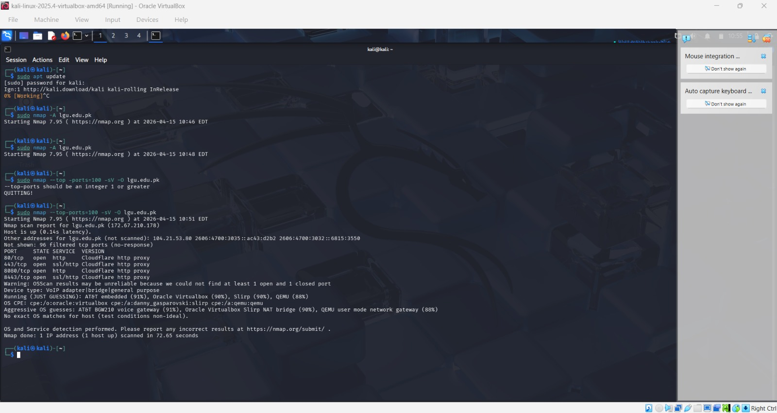
Step 3 — Enumeration
▶ Enumerate Windows / Active Directory (if Windows VM is available)
enum4linux -a 192.168.56.101
This tool extracts users, groups, shares, and policies from Windows/Samba targets.
▶ SMB Enumeration
nmap --script smb-enum-users 192.168.56.101
nmap --script smb-enum-shares 192.168.56.101
▶ Additional Enumeration with Nmap Scripts
nmap --script=nbstat 192.168.56.101 # NetBIOS info
nmap --script=snmp-info 192.168.56.101 # SNMP info
nmap --script=dns-brute 192.168.56.101 # DNS brute force
Step 4 — Document Your Findings
▶ Write a Scan Report
Record the following for each host found:
- IP address and hostname
127.67.210.178 and LGU.edu.pk
- Open ports and services running
80: htts
445:ssl
8080:http
- Operating system detected
Hide due to cloudflare
- Any vulnerabilities flagged by Nmap
While these ports are standard for web applications, the presence of 8080 and 8443 can sometimes indicate alternative management interfaces or development environments. However, since they are identified as Cloudflare http proxy, they are likely just part of Cloudflare's standard edge network listener range.
2. Service Fingerprinting
•
In your specific scan of lgu.edu.pk, the service fingerprinting result is essentially a "False Positive" regarding the backend server.Because the target uses Cloudflare, Nmap’s -sV (Service Version) probes were answered by a Web Application Firewall (WAF) rather than the actual university server.

- Any users/shares found during enumeration
The scan,I ran is a Service/Version scan, which tells you what is running, but not what data is inside it. Even though ports 80 and 443 are open (which host the website), Nmap won't list the files on that website unless you use specific scripts or different tools.
🎯 Goal: A complete scan report listing active hosts, open ports, running services, OS info, and enumerated users/shares — with potential vulnerabilities identified.

